Instructor Prep EMAIL to FIRST STEPS®
Facilitator Certification COURSE Participants
Thank you for registering for the upcoming Respecting Choices® First Steps® ACP Facilitator Certification Course.

Listed below are requirements you must fulfill to become certified as a Respecting Choices (RC) First Steps ACP Facilitator.
- Complete the First Steps ACP Facilitator Online Core Curriculum: Modules 1−4.
Below (on page 2) are the instructions for accessing your online learning modules. Please note: You must complete all four modules prior to attending the classroom course. Allow 4-6 hours to complete the online curriculum.
Be sure to complete the online learning by: [insert date, preferably two weeks prior to course]
- Complete Personal Engagement Activity.
Purpose: To gain an understanding of common perceptions that people have regarding advance care planning (ACP).
Instructions: Attempt to have a conversation with a loved one or close friend. Ask this person the following questions:
- What is your understanding of advance care planning?
- What type of advance care planning have you done, if any?
- What fears or concerns do you have about this type of planning?
- Review the attached Advance Directive document.
Purpose: To increase awareness and understanding of the advance directive document used in your organization and community.
- Achieve First Steps ACP Facilitator certification with competency demonstration in facilitating a First Steps ACP conversation.
There will be time in class to practice facilitation skills. You will participate in role-play exercises throughout the day to demonstrate competency expectations in these skills. The ACP communication skills described in the online course will assist you in preparing for the role-play exercises.

I look forward to meeting you!

(Instructor’s signature)

(Instructor’s name)
(Instructor’s title)
(Instructor’s contact information)
Respecting Choices Certified First Steps ACP Instructor

NOTE: The term “certification” as used in Respecting Choices® educational programs and products means that Respecting Choices issues a certificate upon fulfillment of the following elements: 1) completion of a specified Respecting Choices educational program with standardized content and processes; 2) successful demonstration of skills associated with the specified program; and 3) if applicable, an 80% or higher score on a written examination associated with the specified program.
Welcome to Respecting Choices Online Learning!

Please follow the instructions below.

An in-depth registration and troubleshooting guide is included starting on page 3.

- Go to www.learnrc.org.
- Click on “System Requirements” in left menu to verify that your computer meets minimum requirements for viewing modules. If your system does not meet minimum requirements, the online modules may not work correctly.
  - We recommend using Google Chrome or Mozilla FireFox as your browser.
  - Headphones or speakers are needed for module audio.
- Create account by clicking “Register Now.” Do not use access code as username or password. Create username and password unique to you.
- After registering, click “Enter Access Code” icon on right of screen.
Insert this Access Code:
[Copy and paste instead of retyping to be sure you are using the correct code.]
- Click “Home” icon in upper left corner.
- Training should be listed under “Incomplete Courses.” Click “Start” next to course title.

After completing all course-specific modules and the evaluations, you will receive access to print continuing education certificates. Go to https://respectingchoices.org/types-of-curriculum-and-certification/continuing-education/ for complete course information including continuing education credits, conflict of interest statements, and financial disclosures.

You will have two (2) years from the date you redeem the access code to complete and/or review the modules.

If you are having trouble registering, accessing the modules, experiencing technical difficulties with the online learning system, or have any other questions, please call:

Respecting Choices: 608-473-1025
Email: info@respectingchoices.org

Using an Access Code to Set Up Your Training Account

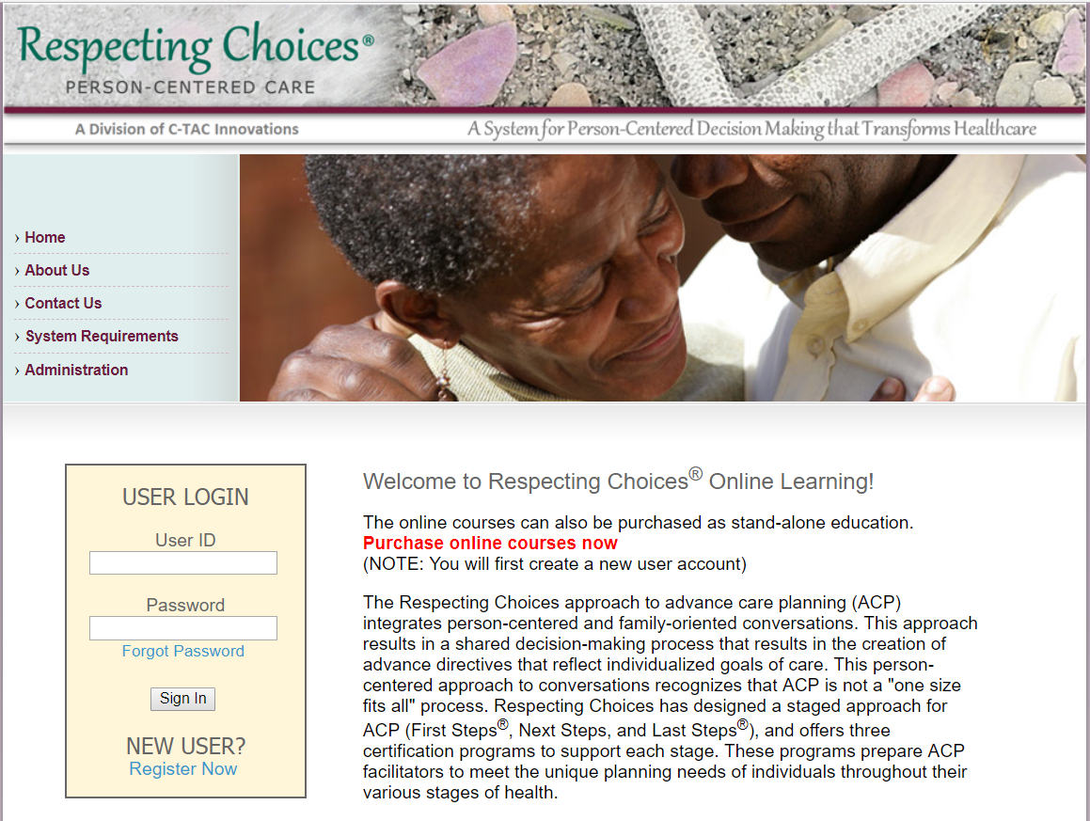
1
Step #1
Go to the website www.learnrc.org. Click the
Register Now link under “NEW USER?”
in the Login box.

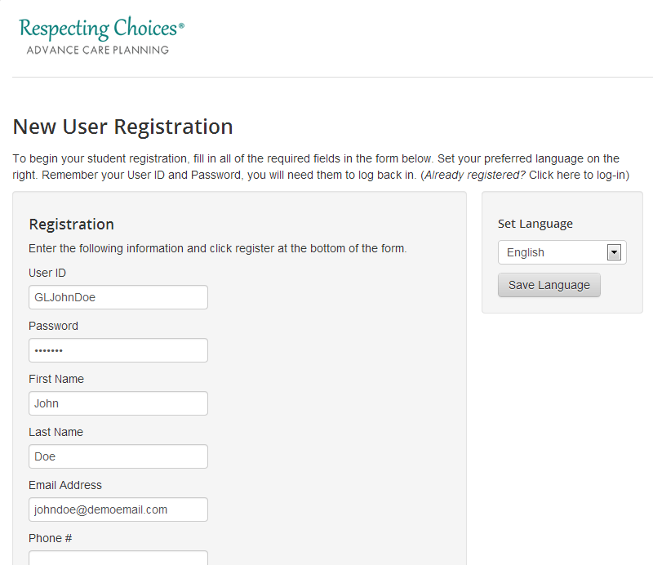
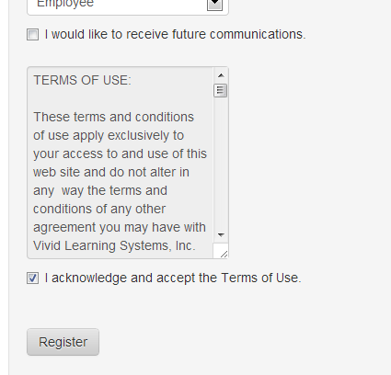
2a
2b
Step #2
The New User Registration page will open. Fill out the information fields, creating a unique User ID and Password.

IMPORTANT – the Access Code is NOT your User ID. Do NOT use the Access Code on this page.

After you’ve read the Terms of Use at the bottom of the page, check the acknowledgement box and click
the Register button.
You are now registered!

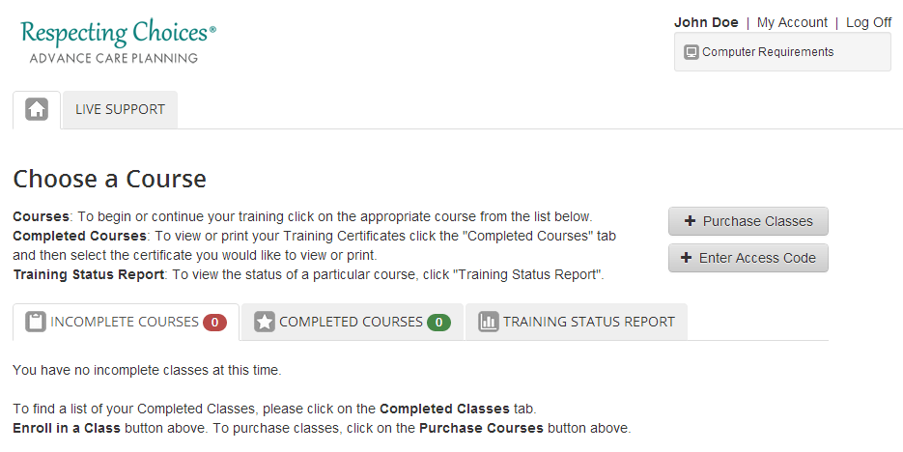
3
Step #3
The window that opens is your Student homepage. To enroll in your classes, click the Enter Access Code button.

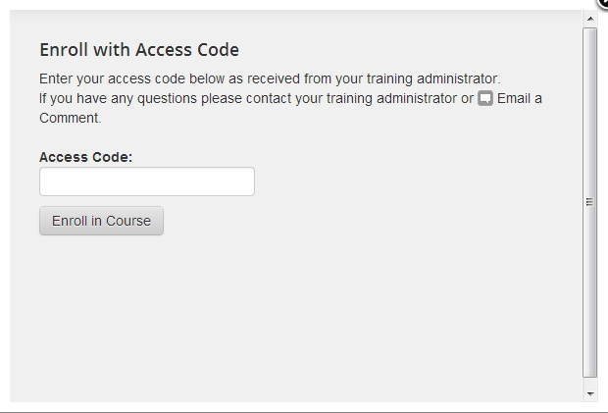
aBcD123EFgh
4a
Step #4
In the window that opens, enter your Access
Code and click the Enroll in Course button.
You are now enrolled in all courses
associated with that Access Code!

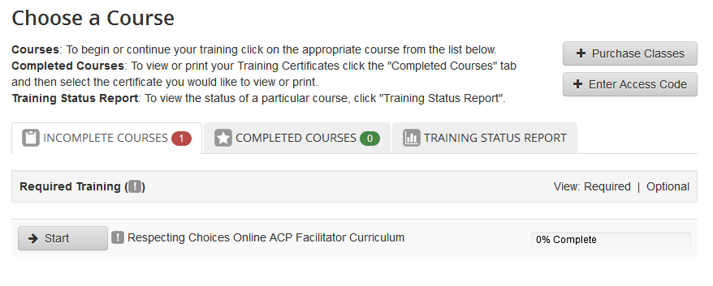
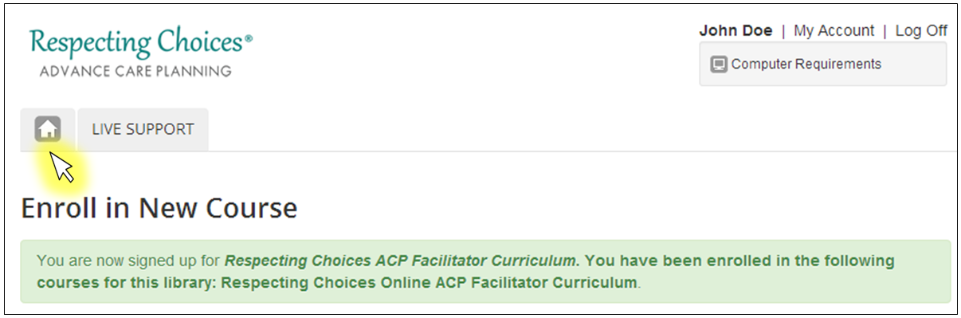
4b
Click the button to return to your
Student homepage. Click on Start
to begin your training.

Returning to Your Training Account

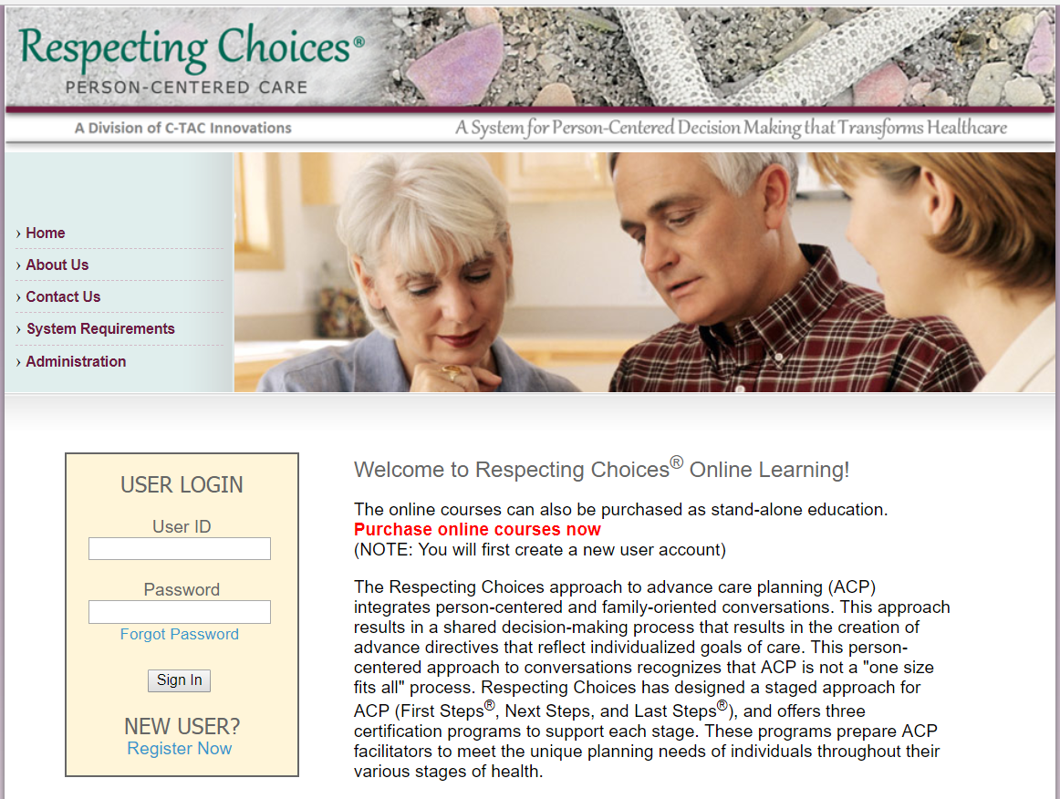
STEP #1
1,2
Go to your web browser and type in: http://www.learnrc.org/

STEP #2
Type in your User ID and Password, then click
Sign In.
(If you have not already created a User Profile using the Register Now
link, refer to page 2 and follow the instructions to register.)

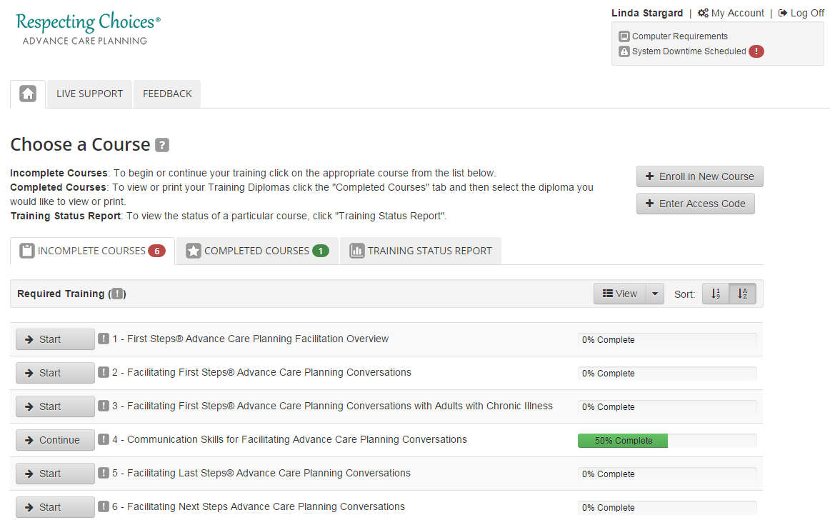
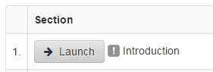
3
4
STEP #3
The system will open up on
the Home tab, displaying a
list of your Incomplete Courses.
Click a Start Button to select a class
to begin.

STEP #4
You will then see the Course Menu
for the class you selected. Click the Launch button for the Introduction
to begin viewing lessons.

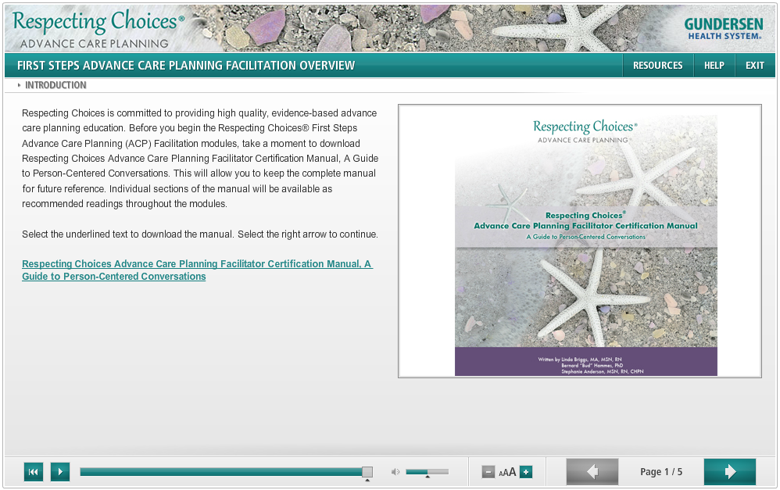
5

STEP #5
When the course loads, it will open in a new window.* Click the arrow buttons† at the bottom to navigate through the course.

* Make sure your Pop-Up Blockers are turned off.
† If you do not see the arrow buttons, try expanding the size of your browser window.

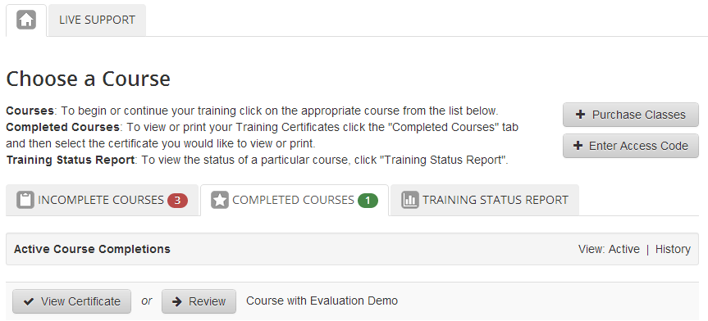
STEP #6
6
Once you have reviewed all content sections including the Test, please complete the Course Evaluation, listed as the last section. After you have done the evaluation, you may print your completion certificate.

After completing a course, your course
will display on the Completed Courses tab
under the Home tab, where you may
click on View Certificate to print your certificate.

To begin another course, click on the Incomplete Courses tab and click another Start button.

Troubleshooting
If you are having trouble, you may use the Comments link at the bottom of the page to Email Customer Support.

You may also click on the Computer Requirements link at the top of the page.
It will test a few settings on your computer and let you know if your system needs adjusting.
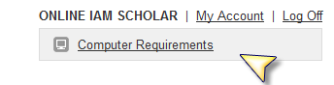

Settings that cannot be tested may also need attention.

Issue | Recommended Solution
You have reviewed all the sections, but your checkmarks are not being recorded. | - Update your Internet Browser Cache setting  - Tools Menu (or icon) > Internet Options > General tab > Browsing History > Settings button  - Check for newer versions of stored page:  Every time I visit the webpage
You click on the next course and it displays the one you have already completed. | Update your Internet Browser Cache setting  (See instructions above)
You are stuck on the loading dots. | - Check to be sure your machine/network is not blocking streaming media  - Check to be sure you have Adobe Flash Player, version 11 or later, installed on your machine  - Check to be sure your Adobe Flash Player settings are set to allow at least 100MB of data to be downloaded to your machine
The template window loads but the center is white (no loading dots). | Check to be sure you have Adobe Flash Player, version 11 or later, installed on your machine
You click on the “Launch” button and nothing happens. | Turn off all of your Pop-Up Blockers (check your internet browser and all toolbars)
Your certificate prints on two pages. | Adjust your printer setting to “Shrink to one page” or “Scale to fit”

If the recommended solutions above do not fix the problem, please contact Respecting Choices at info@respectingchoices.org.

