First Steps® ACP Instructor

Certification requirements

Prerequisites
- Submit signed First Steps ACP Instructor Agreement.
- Complete First Steps ACP Facilitator Certification course, including the First Steps ACP Facilitator Online Core Curriculum (modules 1 – 4).
- Complete Respecting Choices® First Steps ACP Design and Implementation course (or local program equivalent).
- Attend First Steps ACP Instructor Certification Course

Certification Components
Overview
Respecting Choices (RC) offers an opportunity to qualified participants to become certified RC First Steps Advance Care Planning (ACP) Instructors. Certification is required to teach the RC First Steps ACP Facilitator Certification course and to use any of the First Steps ACP Facilitator Certification course materials.
The RC First Steps ACP Instructor agrees to 1) teach the RC First Steps ACP Facilitator Certification course within a specified organization or community, and 2) use the standardized course materials provided – including the First Steps ACP Facilitator Online Core Curriculum. Please review the terms in the First Steps ACP Instructor Agreement for more information.
Learning Outcomes
At the conclusion of the course, participants will be able to:
- Define Instructor responsibilities and common strategies for teaching the RC First Steps ACP Facilitator Certification course.
- Facilitate a brief discussion on a selected ACP topic.
- Apply three mentoring strategies to promote Facilitator certification and maintenance of competence.
- Apply at least three Instructor mentoring strategies during role-play activities.

Agenda
8:00 am Welcome and Introductions
  - First Steps (FS) Advance Care Planning (ACP) Instructor Role and Responsibilities
  - Instructor Certification Materials and Copyright Restrictions
  - Role and Responsibilities of the Instructor
8:30 Preparing to Teach Your Own First Steps ACP Facilitator Certification Course
9:00 The Role of the Instructor: Teaching and Presentation Strategies
10:10 Certification Exam
10:30 Break
10:45 Instructor-Led Discussions
Instructor candidates will work in pairs (as team teachers) to facilitate a 10-minute discussion with other participants who will role-play typical questions that arise during the First Steps ACP Facilitator Certification course
12:00 pm Lunch
12:30 The Role of the Instructor in Promoting Facilitator Certification and Maintenance of Competence
- Mentoring strategies
- Providing feedback during role-play exercises
1:15 Small Group Activities to Practice Giving Feedback
Each Instructor candidate will practice giving feedback using standardized role-play situations.
3:15 Group Debrief
- What skills did you learn?
- What skills do you want to improve?
3:30 Creating Improvement Plans for Facilitator Competency
4:00 Adjourn

Criteria for Completion of Certification
Each Instructor candidate must review and meet the certification criteria outlined in the Instructor Certification Checklist (RC 1225) in Appendix I.

Preparation for Instructor Certification
The following activities are suggested to prepare you for the certification course:
- Review RC’s Building a Systems Approach for Advance Care Planning manual and content from the First Steps Design and Implementation course for information on key elements in designing an effective ACP program.
- Review the First Steps ACP Conversation Guides and related information from the First Steps ACP Facilitator Certification course.

awarding Certification
Respecting Choices Faculty and Organization Faculty fully anticipate that all Instructor candidates will achieve certification. Faculty will provide necessary support and guidance as appropriate. It is the goal of this certification to produce confident and qualified Instructors who will be teaching others to have First Steps ACP conversations.
If Faculty do not feel that certification is warranted, they will work with you and the local team coordinator to develop a plan to help you achieve certification.
Comprehensive materials. Certified Instructors will be given access to all materials necessary to replicate the standardized RC First Steps ACP Facilitator Certification course. This includes all course handouts, videos, webinars, and Instructor notes that provide teaching and organizational strategies to assist in preparation for and successful delivery of a First Steps ACP Facilitator Certification course.

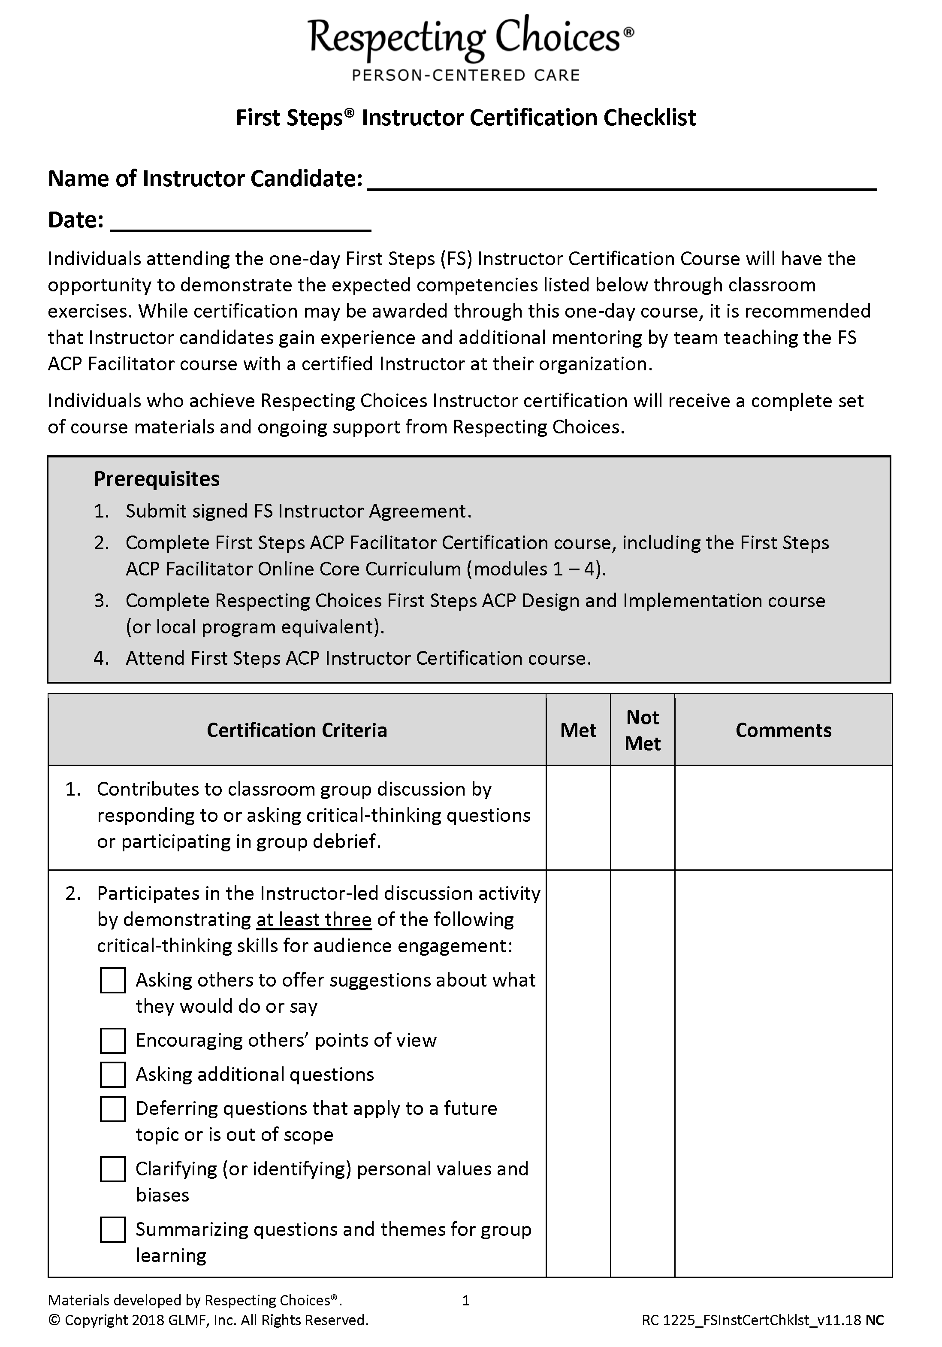
APPENDIX I

